1. msfconsole with the exploit loaded

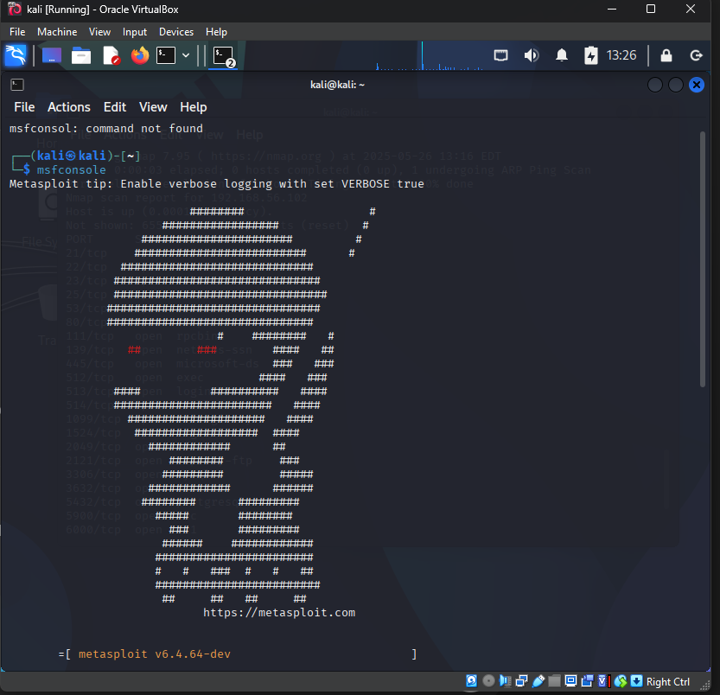

1. Output of run showing shell opened

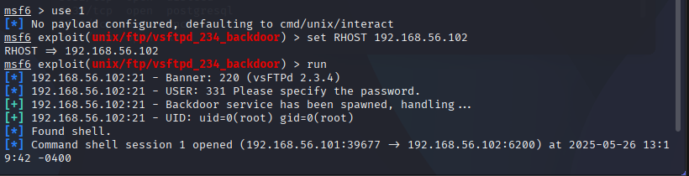

1. Terminal showing whoami, uname -a, etc.

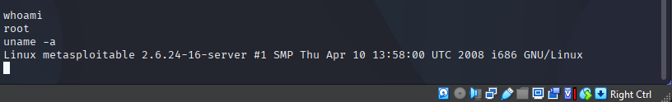

**Short Answers**

1. What vulnerability did you exploit?

Ans: I targeted vulnerable FTP service.

1. What does the vsftpd_234_backdoor exploit do?

Ans: gives me the root access of the target.

1. What is a reverse shell?

Ans: it is a method used my hacker to gain remote access over the targeted system.

1. Why is gaining root access so dangerous?

Ans: it is dangerous as it gives the full control over the system.

1. What are 2 things you can do once inside the system?

Ans: I can create a backdoor, by adding user. I can read files and play with the integrity of the data.